|  |  |  |  |  |
| --- | --- | --- | --- | --- |
| Practical No | Topic | Date | Page No | Remark |
| 1 | Exp1: Data collection, Data curation and management for Unstructured data(NoSQL) with Couch DB. | 05/02/22 |  |  |
| 2 | Exp 2: Practical of Data collection, Data curation and management for Large-  scale Data system (such as MongoDB) | 29/01/22 |  |  |
| 3 | Exp:3 Dimension Reduction using Principal Component Analysis (PCA). | 23-11-2021 |  |  |
| 4 | Exp: 4. Practical of Clustering | 04-12-2021 |  |  |
| 5 | Exp: 5. Practical of Time-series forecasting | 11-12-2021 |  |  |
| 6 | Exp 6. Practical of Simple/Multiple Linear Regression | 15/01/22 |  |  |
| 7 | Exp 7. Practical of Logistics Regression | 18/12/21 |  |  |
| 8 | Exp: 8. Practical of Hypothesis testing | 30/11/2021 |  |  |
| 9 | Exp 9. Practical of Analysis of Variance | 22/02/22 |  |  |
| 10 | Exp 10. Practical of Decision Tree | 12/02/22 |  |  |

Data Science

PRACTICAL NO. 1

Aim: Practical of Data collection, Data curation and management for Unstructured data (NoSQL) Download and install CouchDB

Set up and validate new login credientials

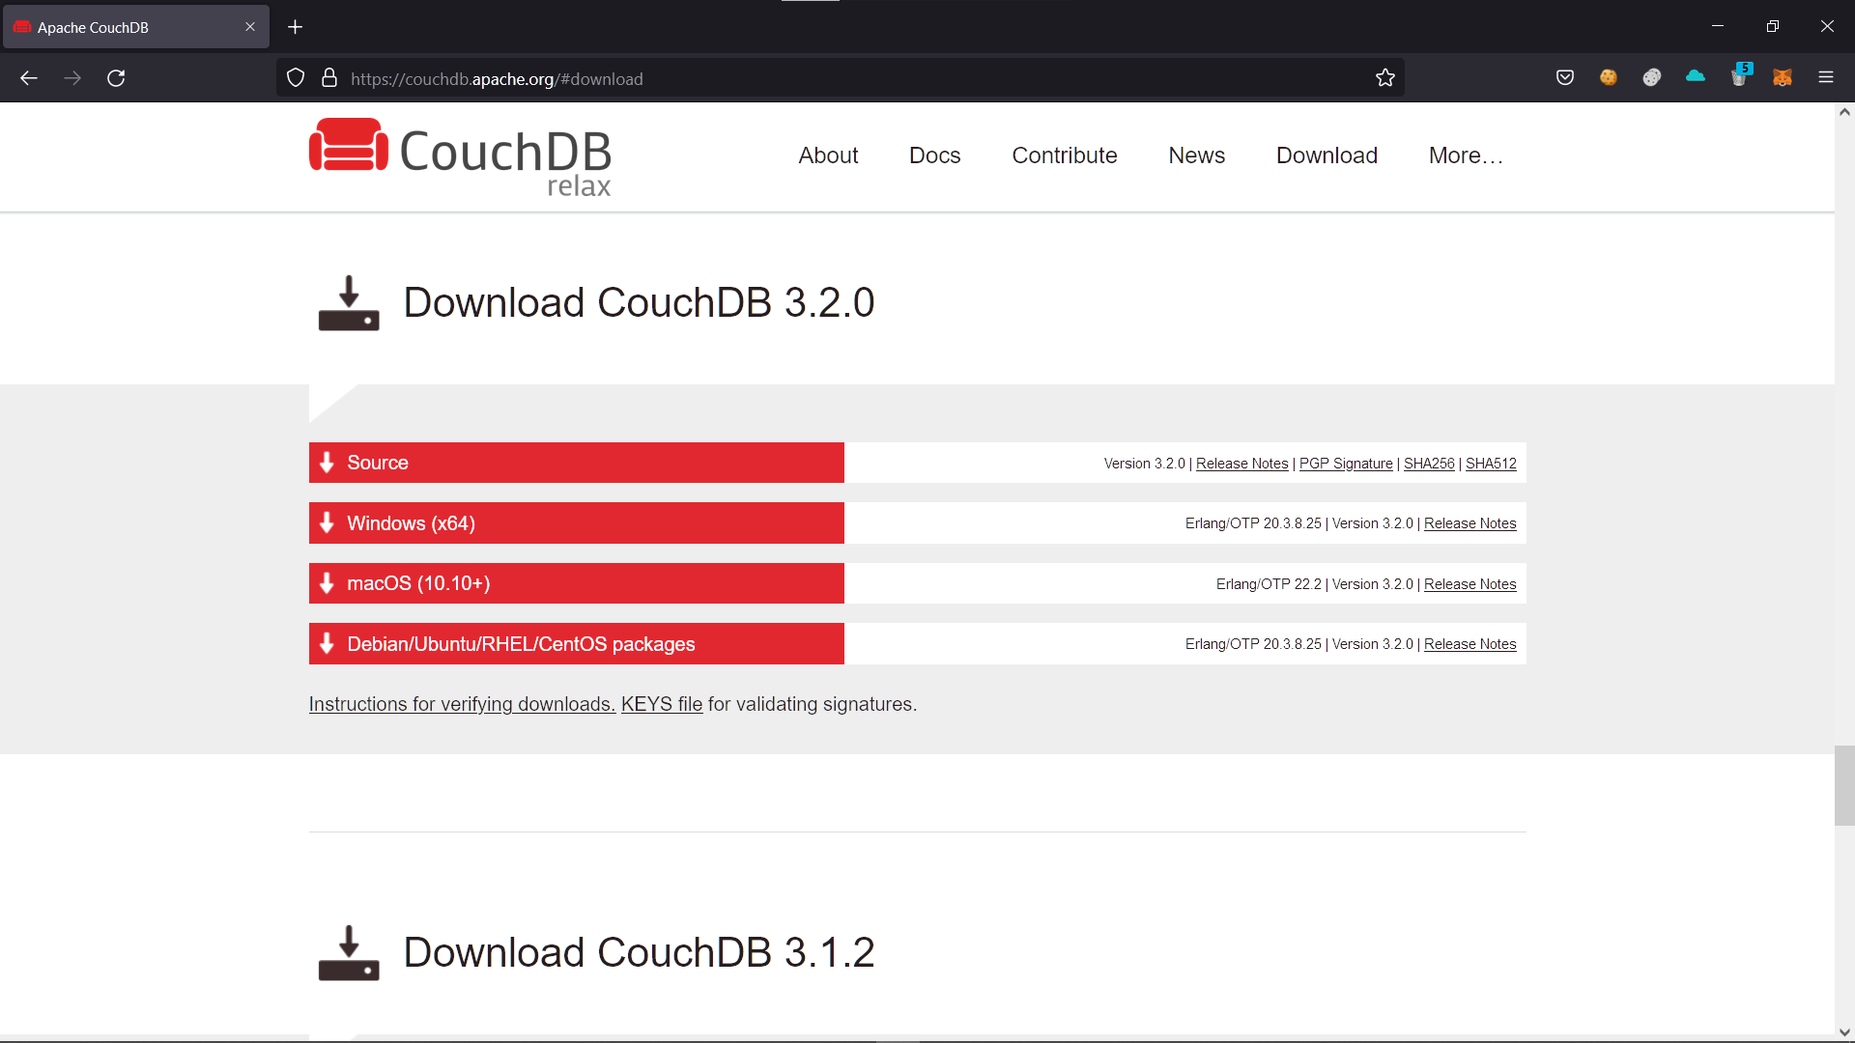

Now visit http://localhost:5984/_utils and enter the credentials

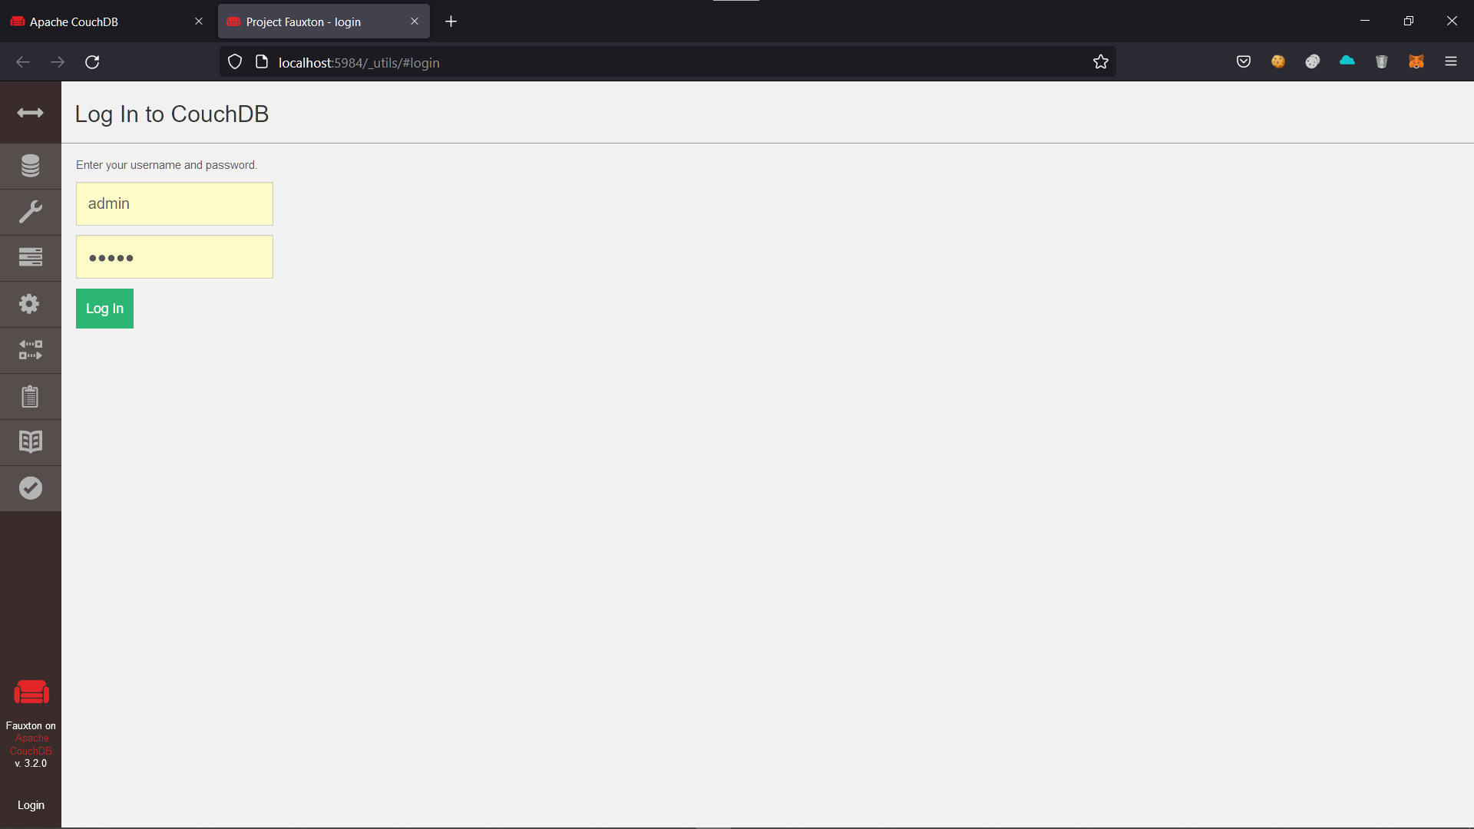

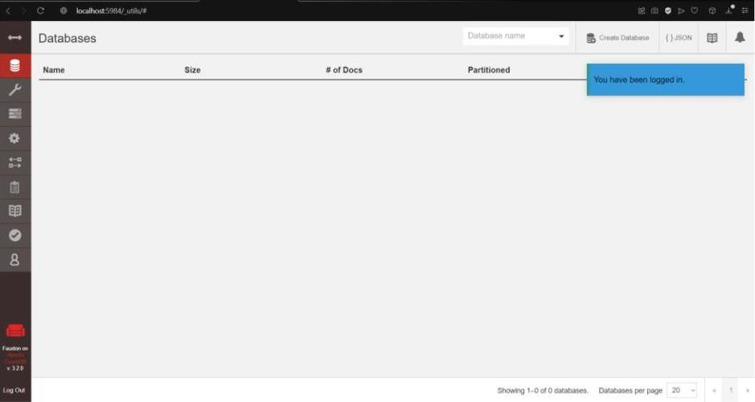

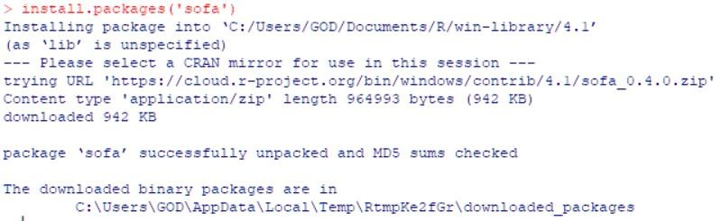Now open r console Install Package

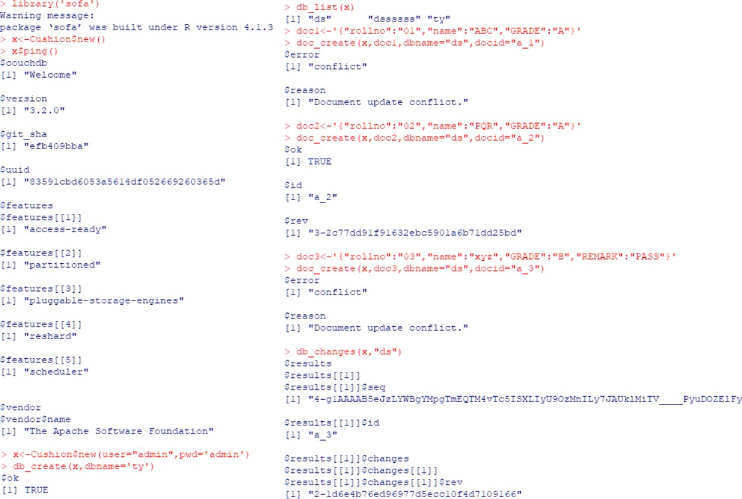Connect to the databse: Insert rows and commit changes:

Query Database

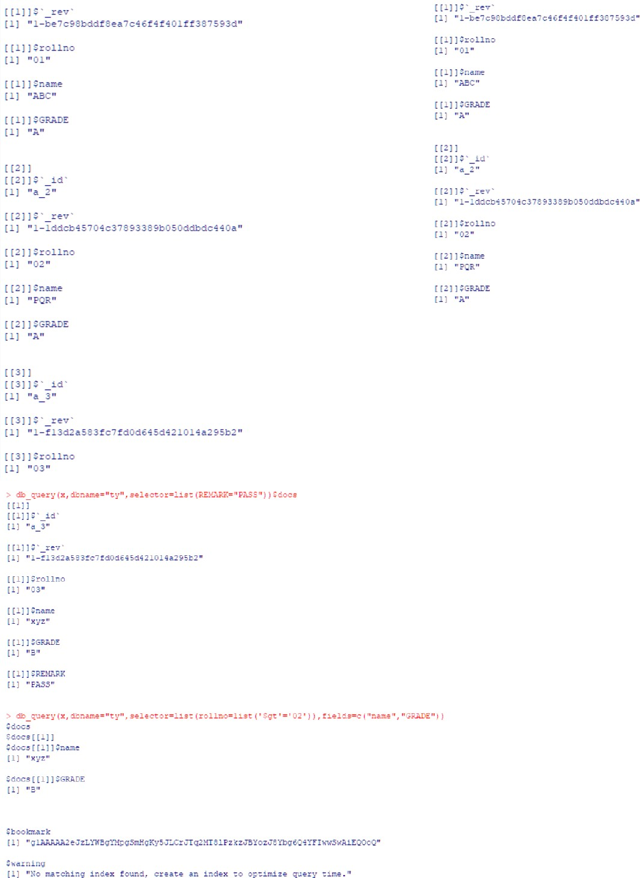

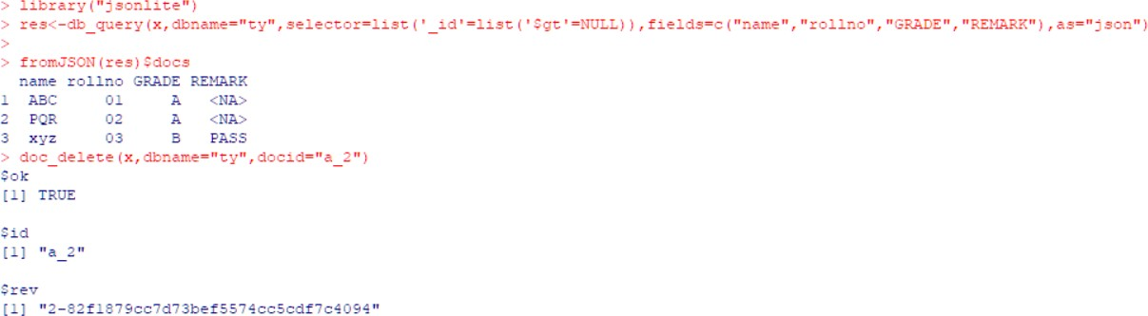Delete Record:

Update a record:

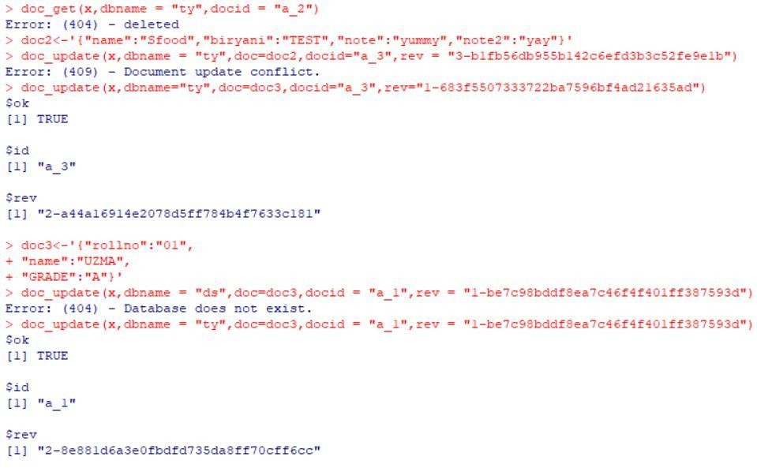

**PRACTICAL NO. 2**

**Aim:** Practical of Data collection, Data curation and management for Large-scale Data system (such as MongoDB)

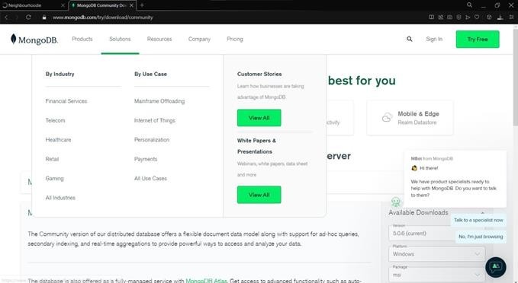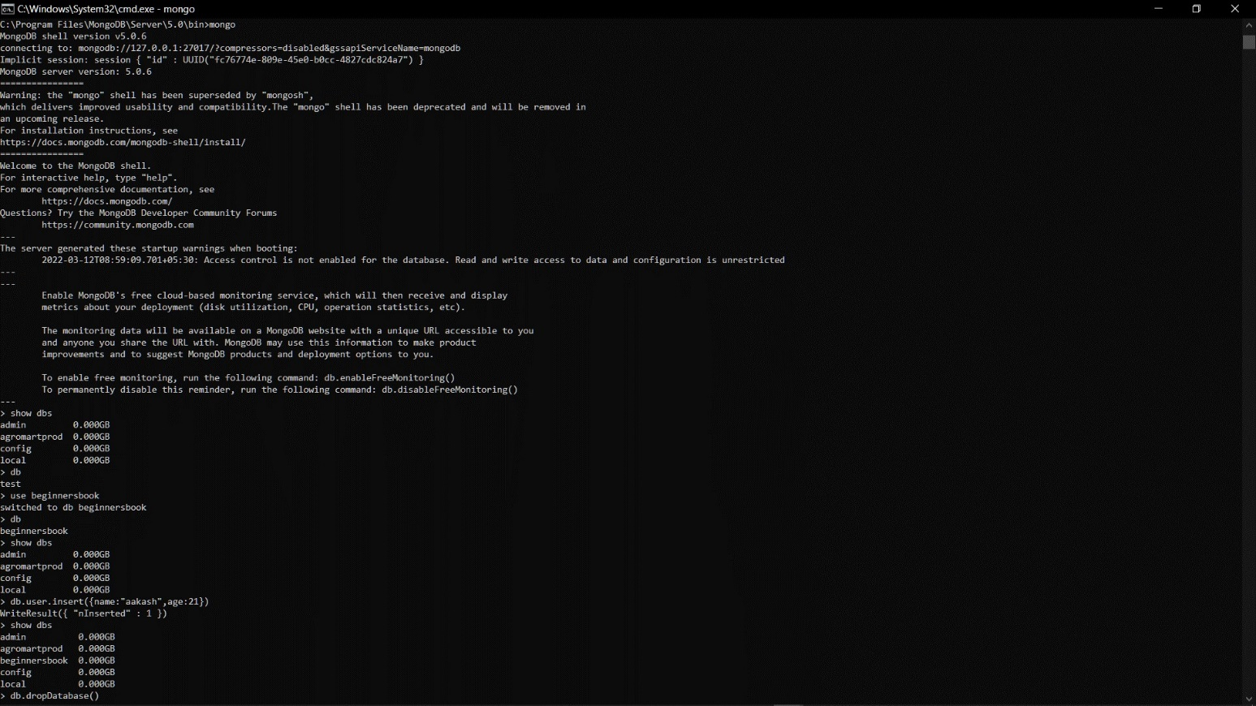

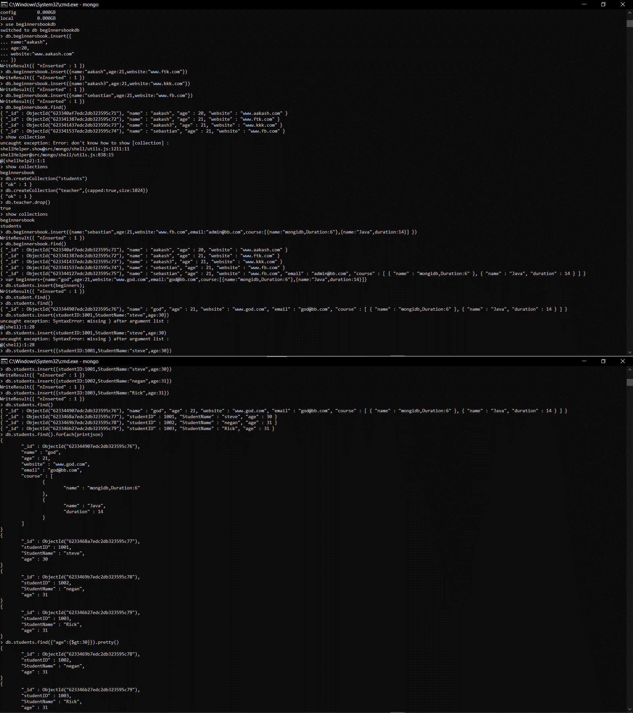

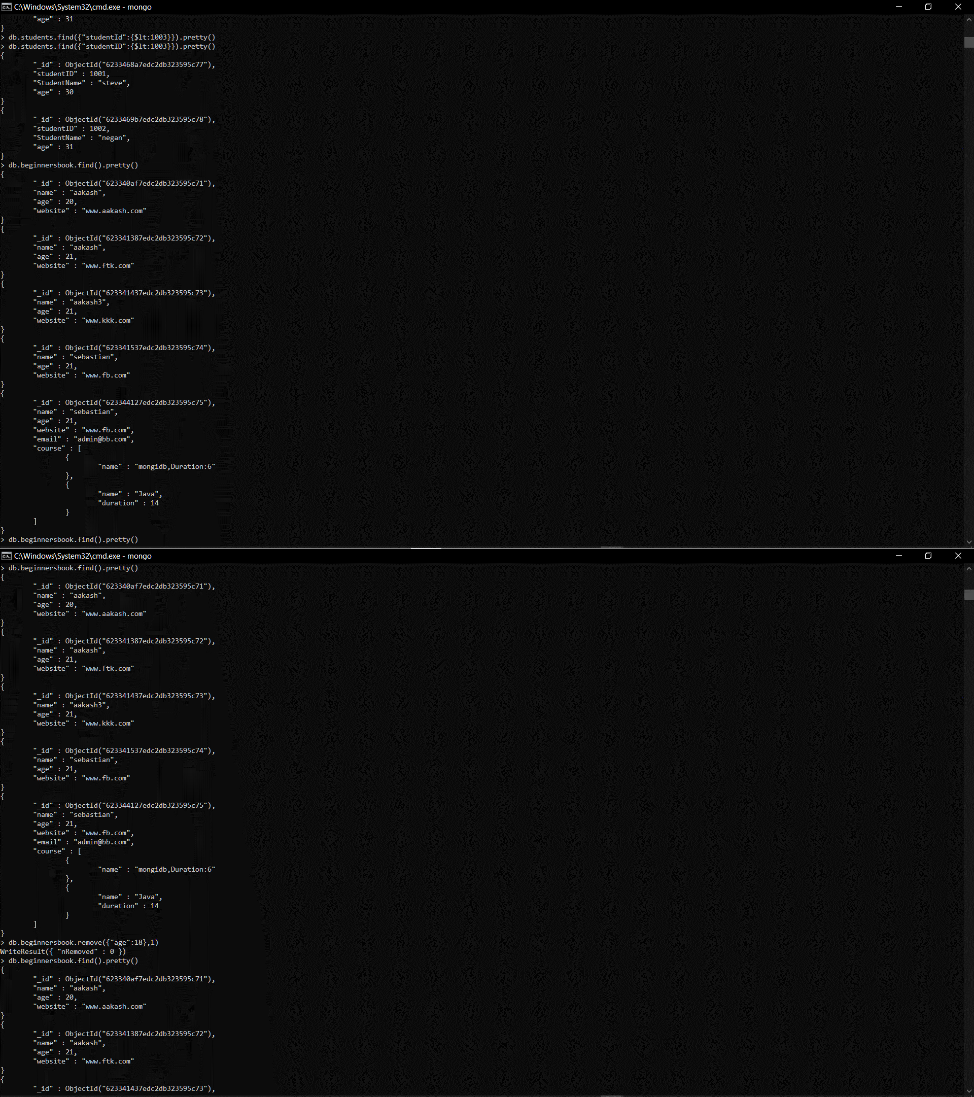

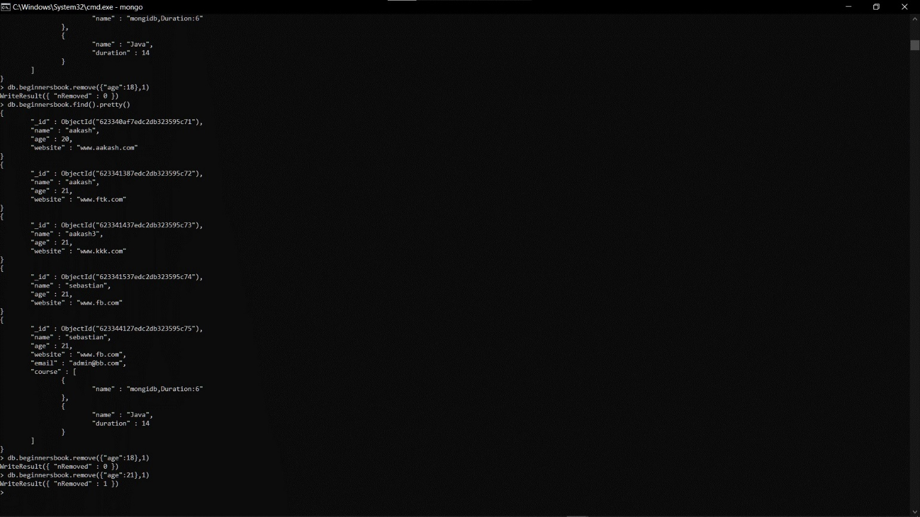

PRACTICAL NO. 3

Aim: Practical of Principal Component Analysis

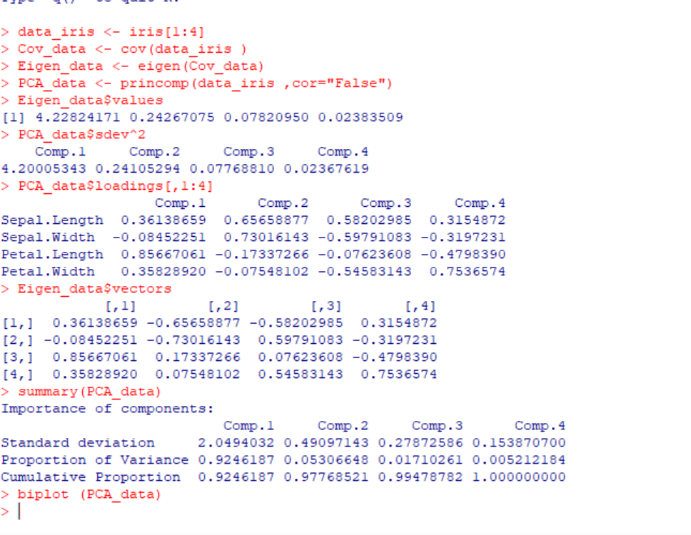

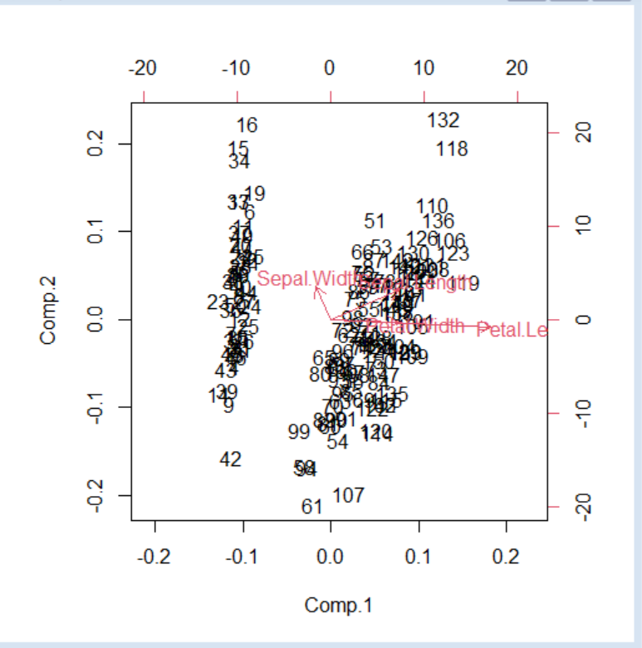

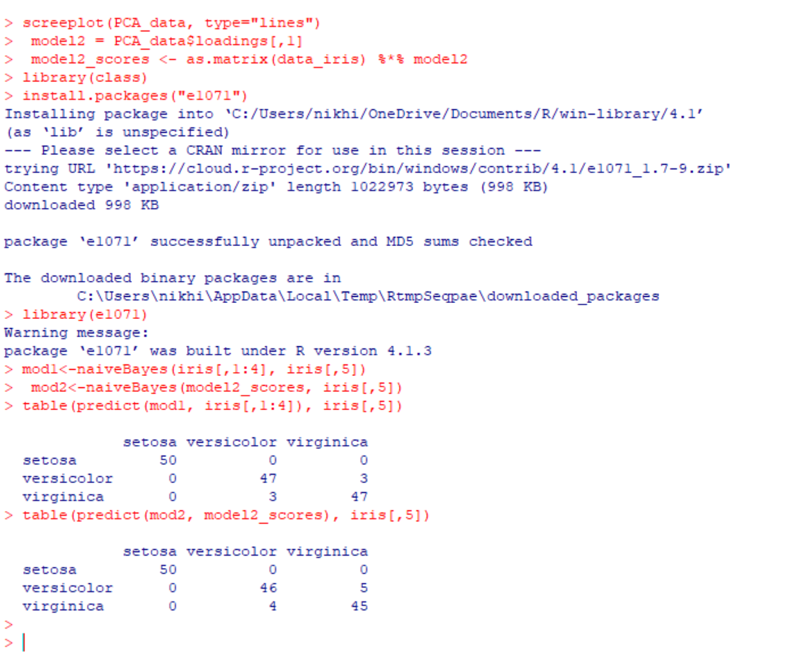

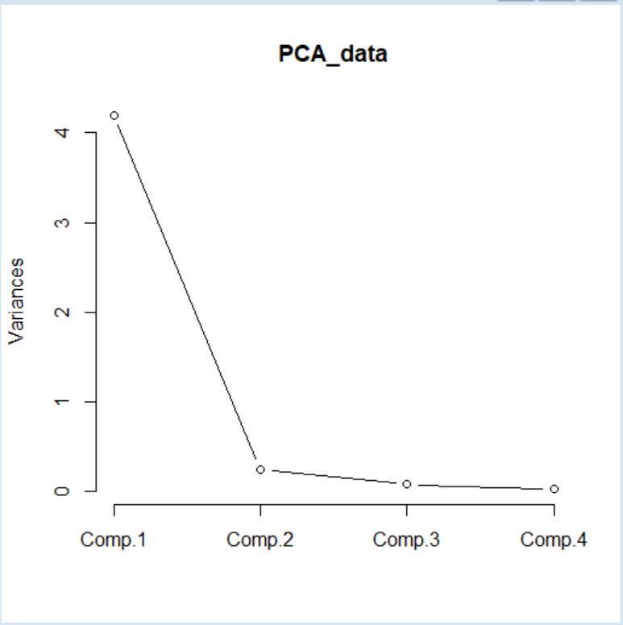

PRACTICAL NO. 4

Aim: Practical of Clustering

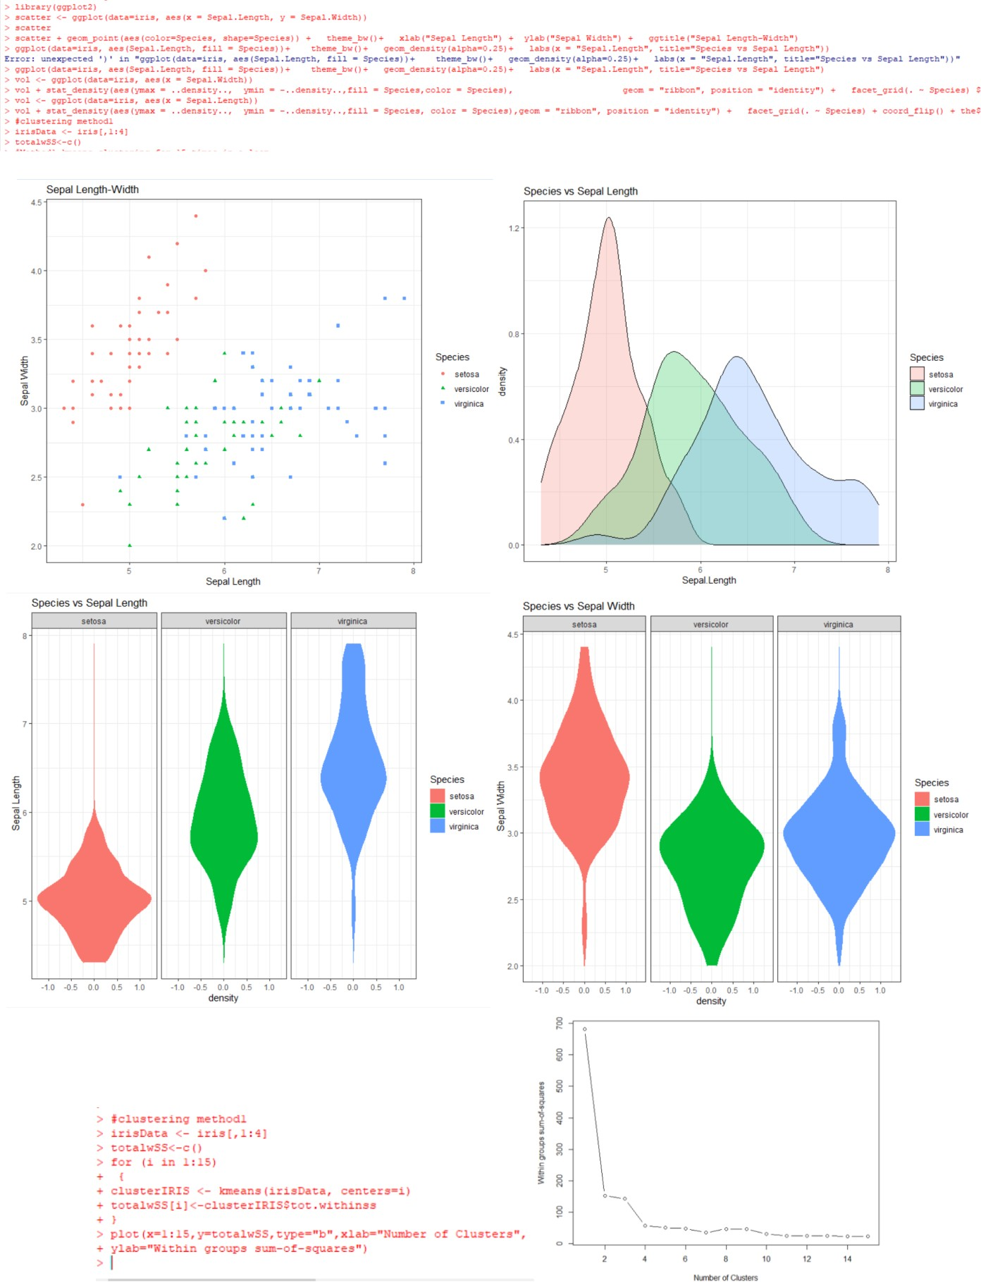

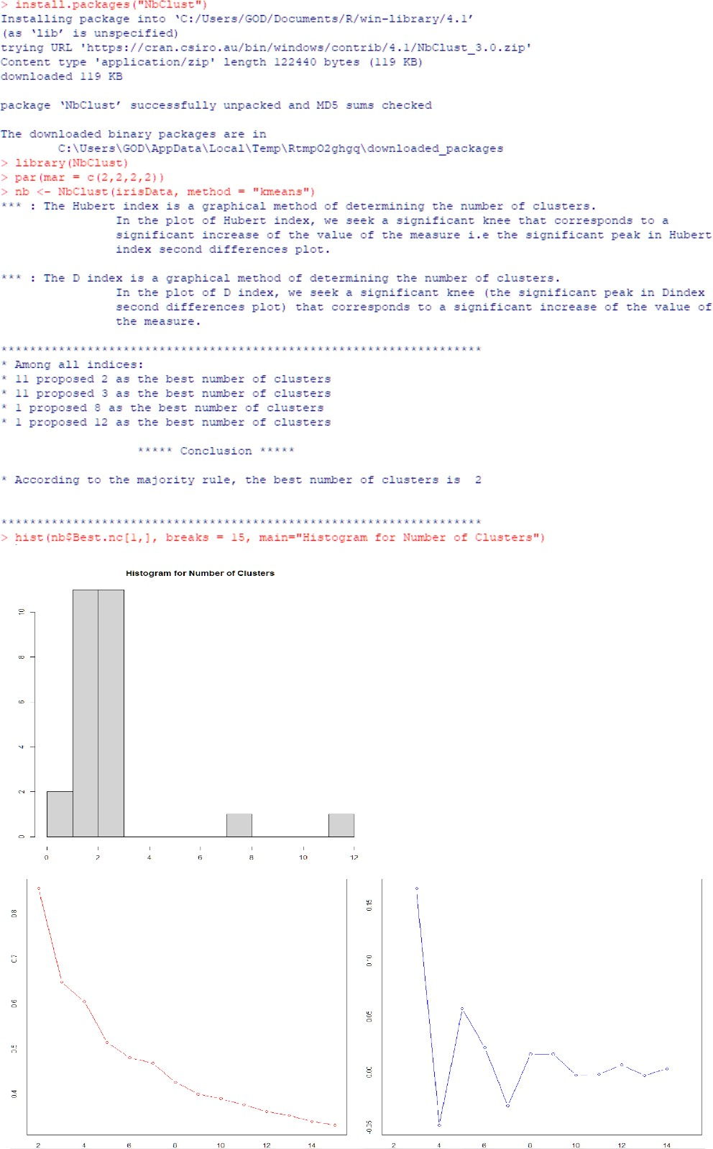

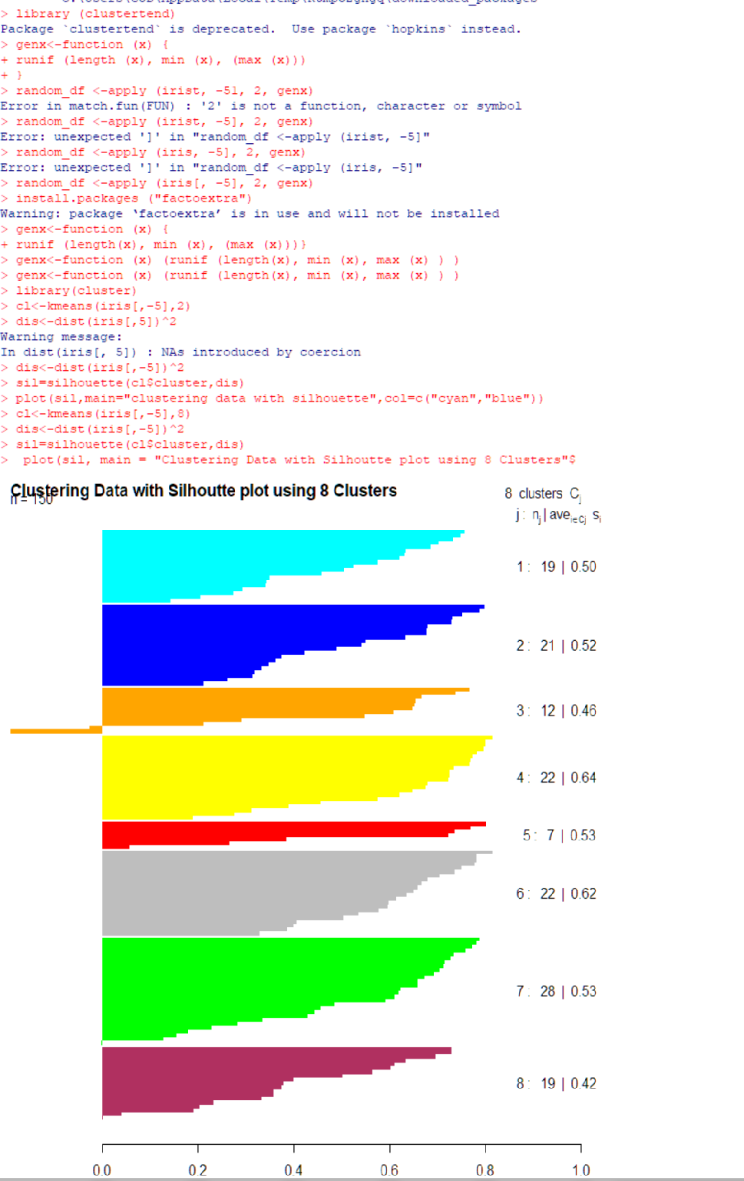

PRACTICAL NO. 5

Aim: Practical of Time-series forecasting

#load Data Airpassenger

data("AirPassengers")

#finding the class name

class(AirPassengers)

#Data In time series format

#start of time series

start(AirPassengers)

#Exp:05

#start of time series

end(AirPassengers)

frequency(AirPassengers)

#The cycle of this time series is 12 month in a year

summary(AirPassengers)

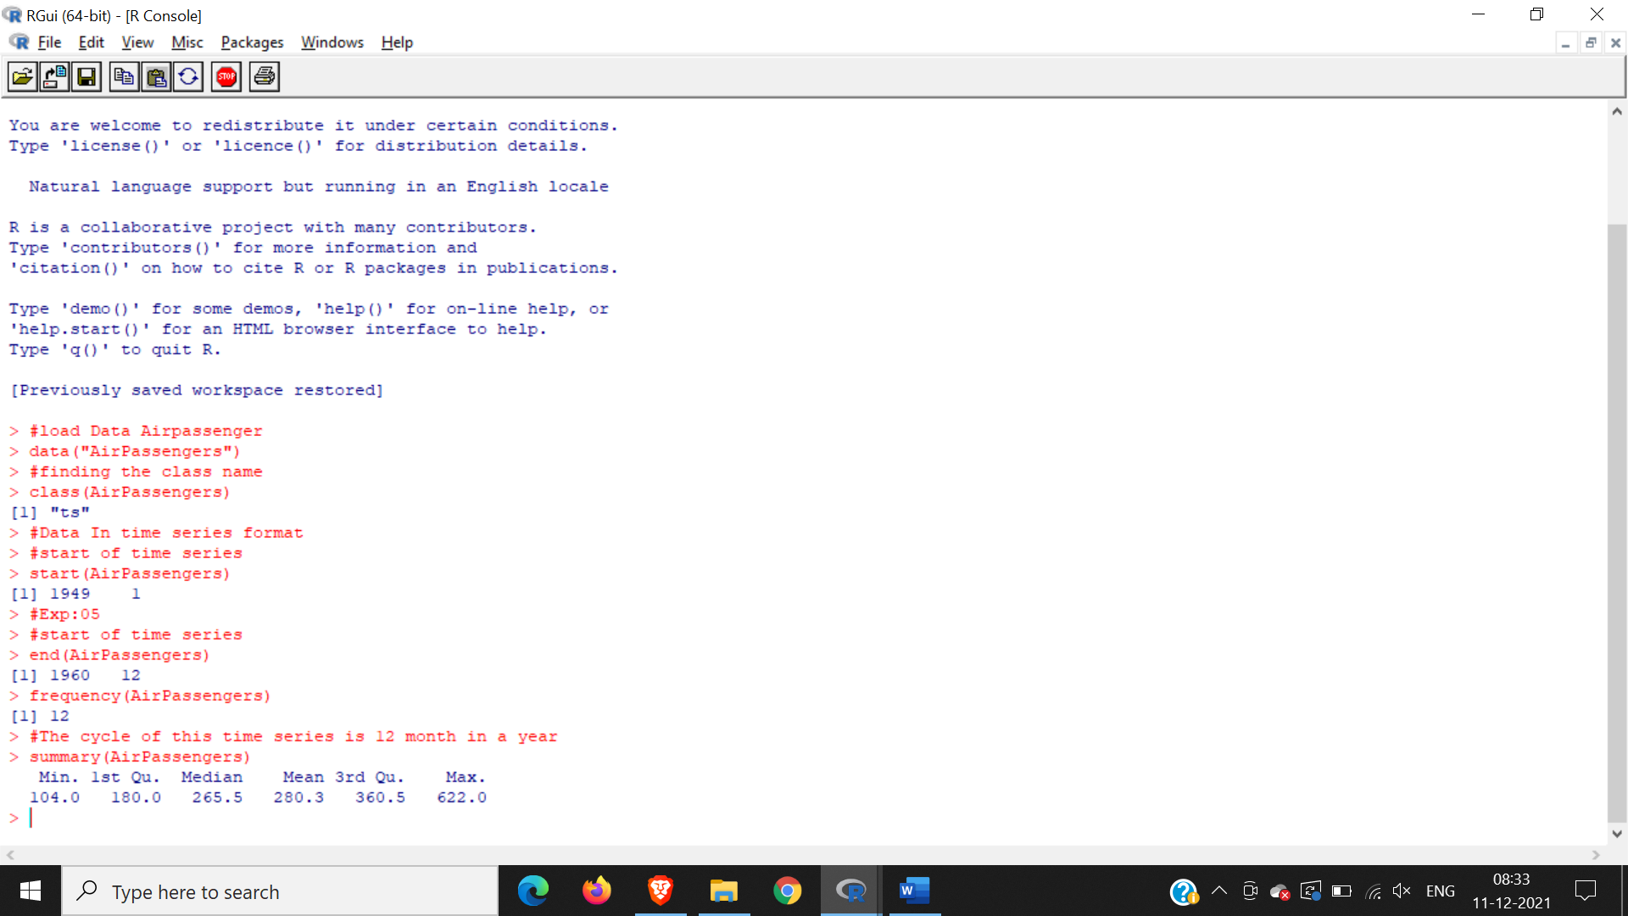

#the number of passenger are distributed across the spectrum

plot(AirPassengers)

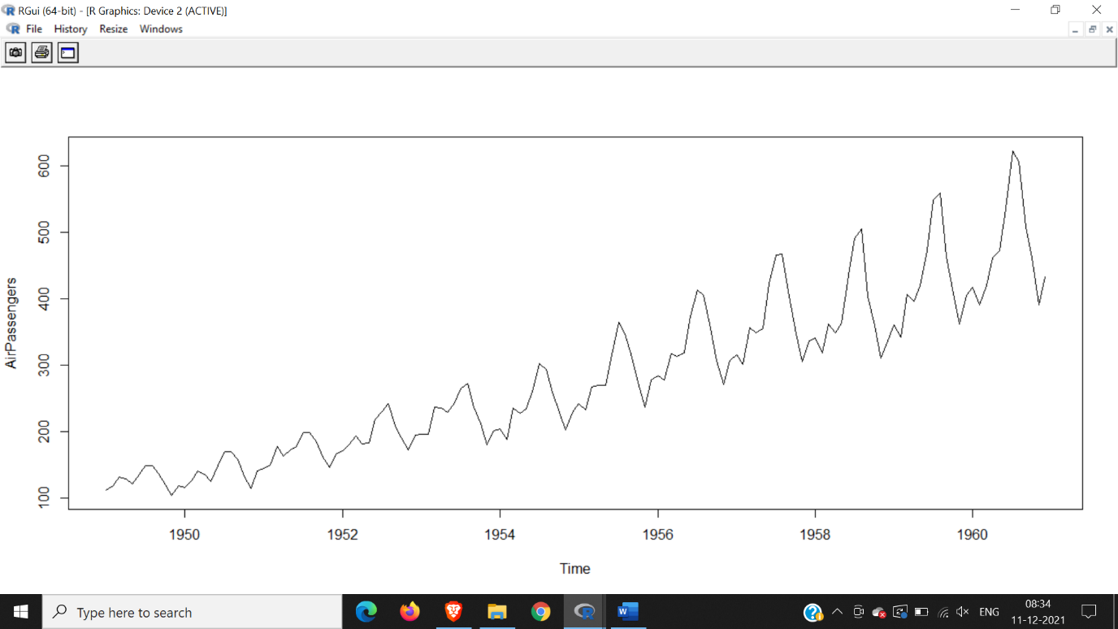

#this will plot the time series

abline(reg=lm(AirPassengers~time(AirPassengers)))

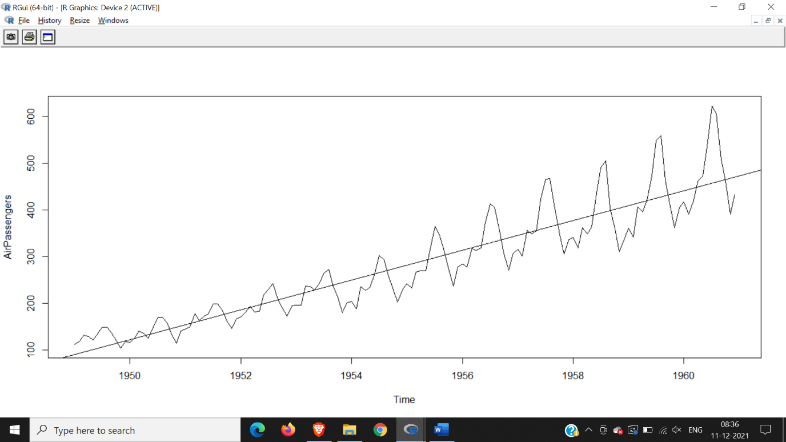

#This will print the cycle across years

cycle(AirPassengers)

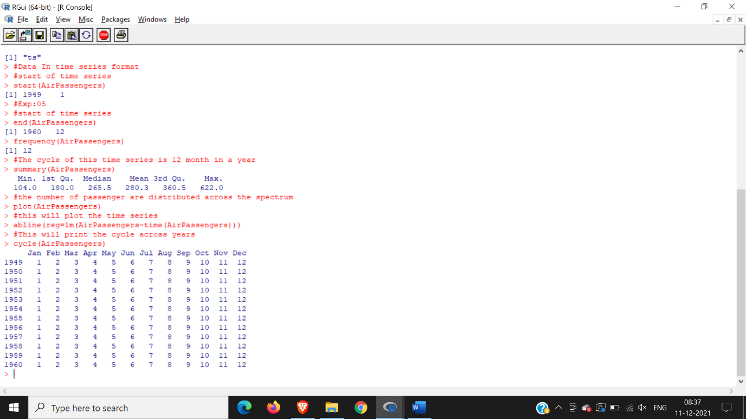

#this wil aggreate the cycles and display a year on year trend

plot(aggregate(AirPassengers,FUN=mean))

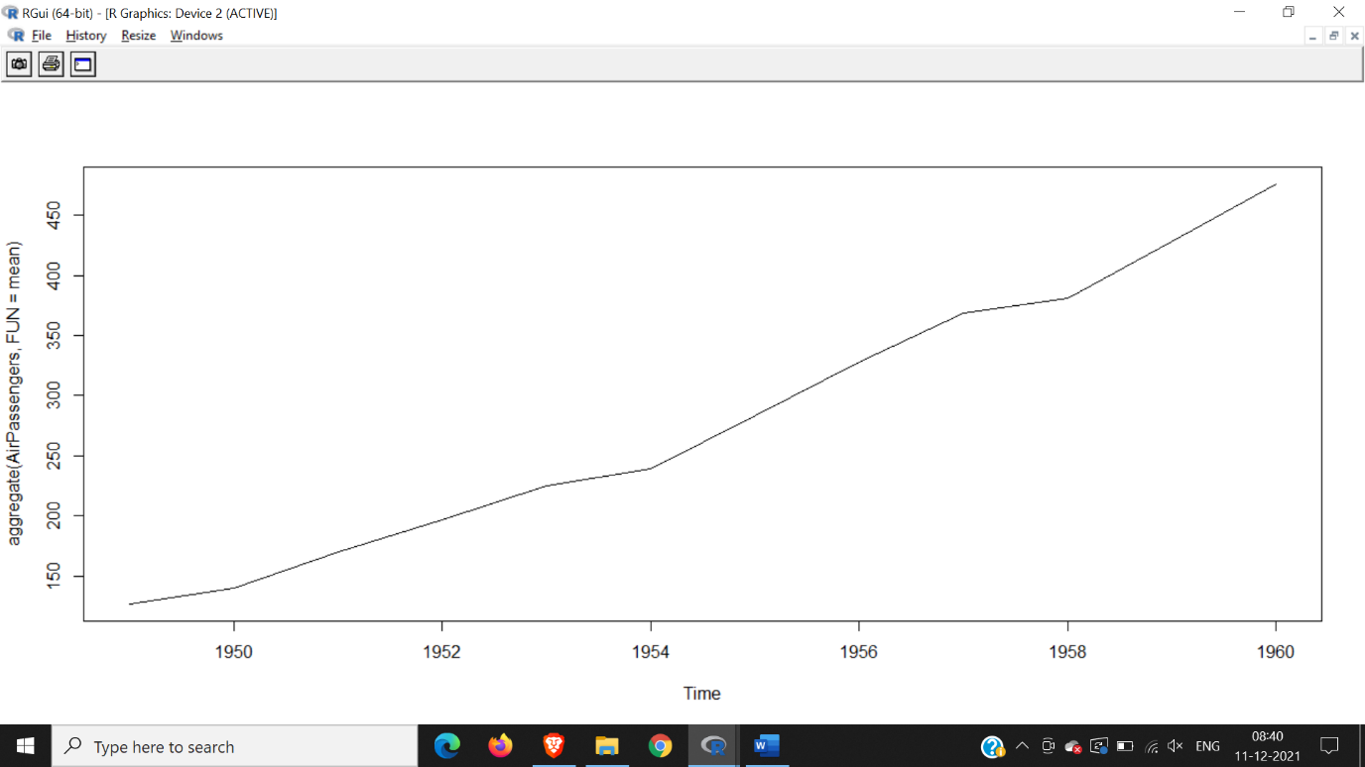

#box plot across month will give us a sense on seasonal effect

boxplot(AirPassengers~cycle(AirPassengers))

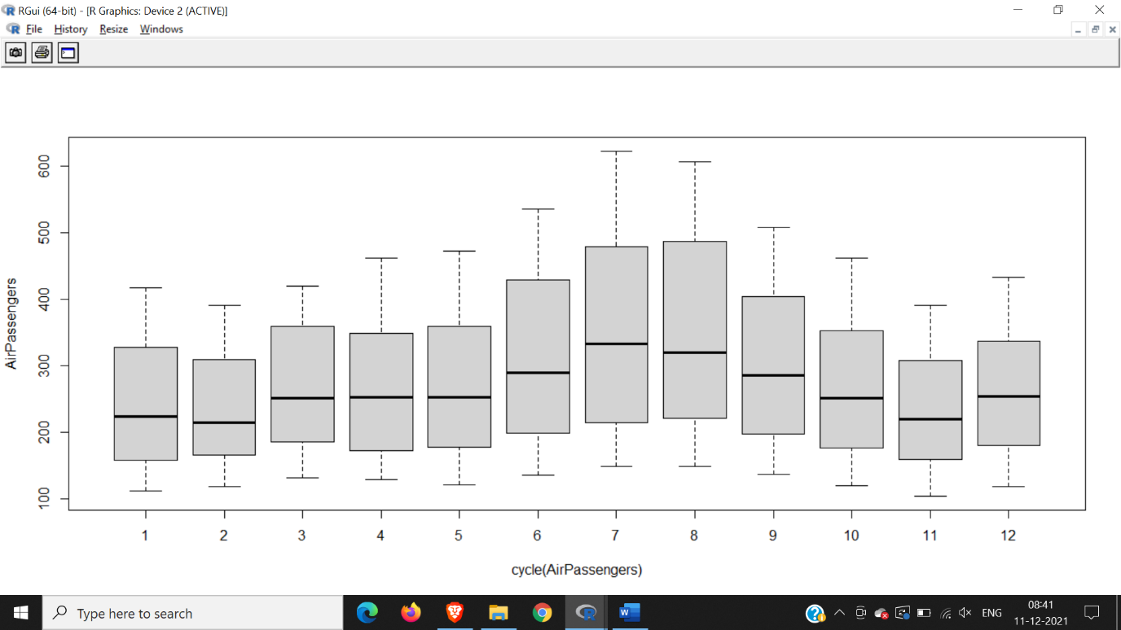

acf(log(AirPassengers))

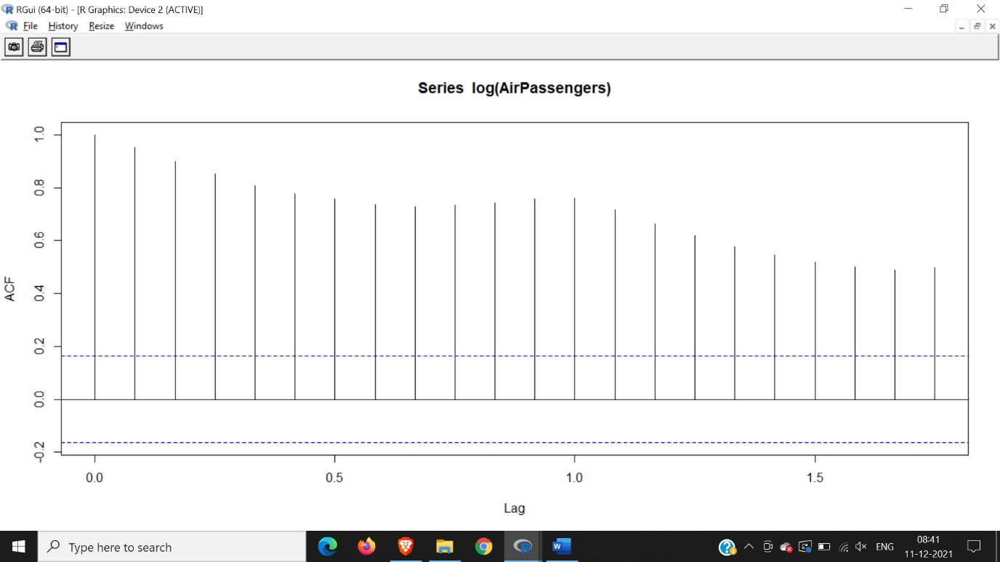

acf(diff(log(AirPassengers)))

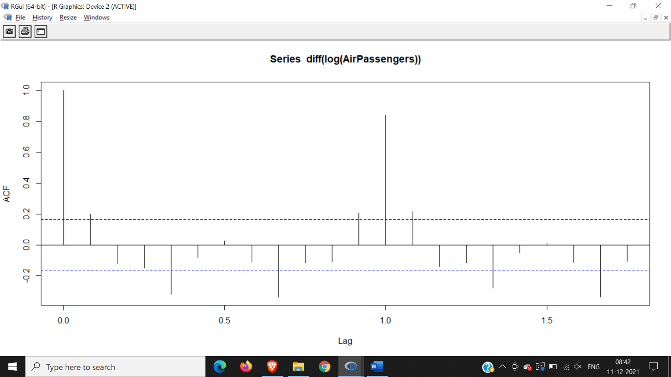

(fit <- arima (log(AirPassengers), c(0, 1, 1), seasonal = list (order= c(0, 1,1),period=12)))

pred <- predict(fit, n.ahead = 10*12)

ts.plot(AirPassengera,2.718^pred$pred,log="y",lty=c(1,3))

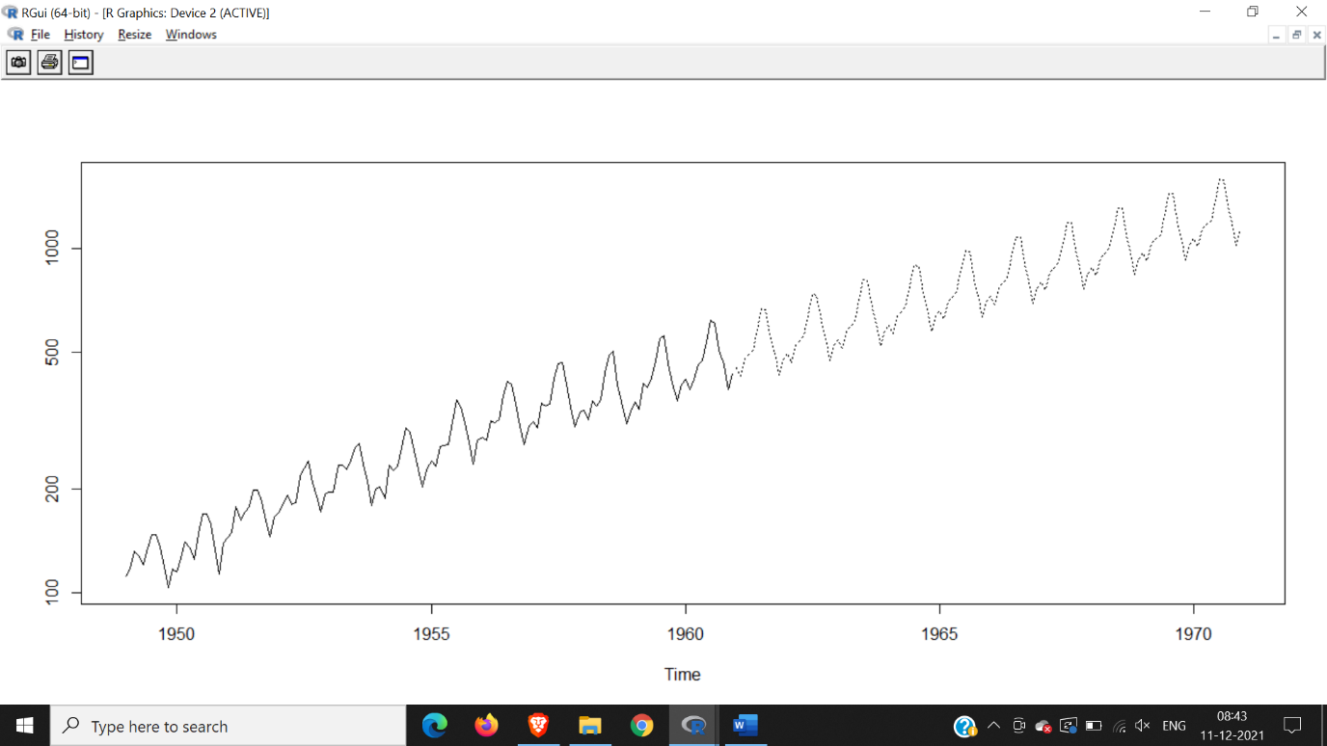

Hence we conclude there will be a rise in passengers

PRACTICAL NO. 6

Aim: Practical of Simple/Multiple Linear Regression

**SIMPLE :**

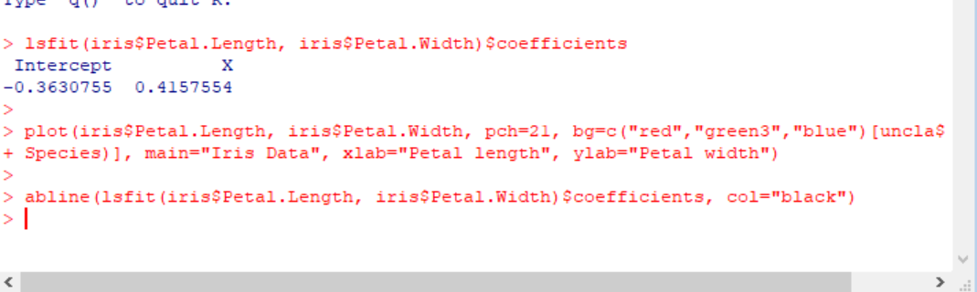

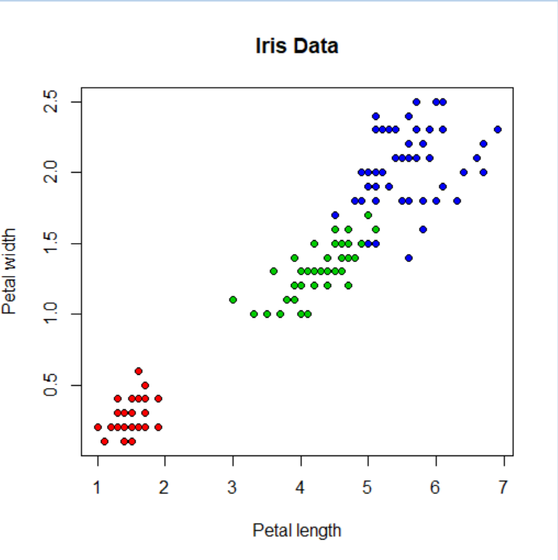 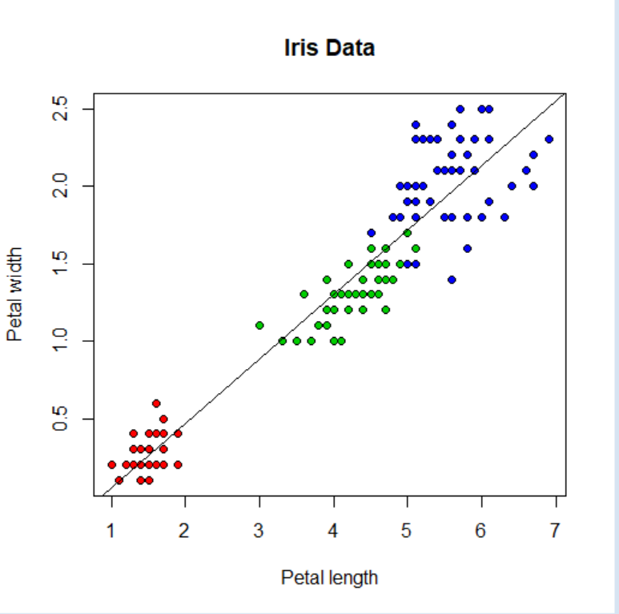

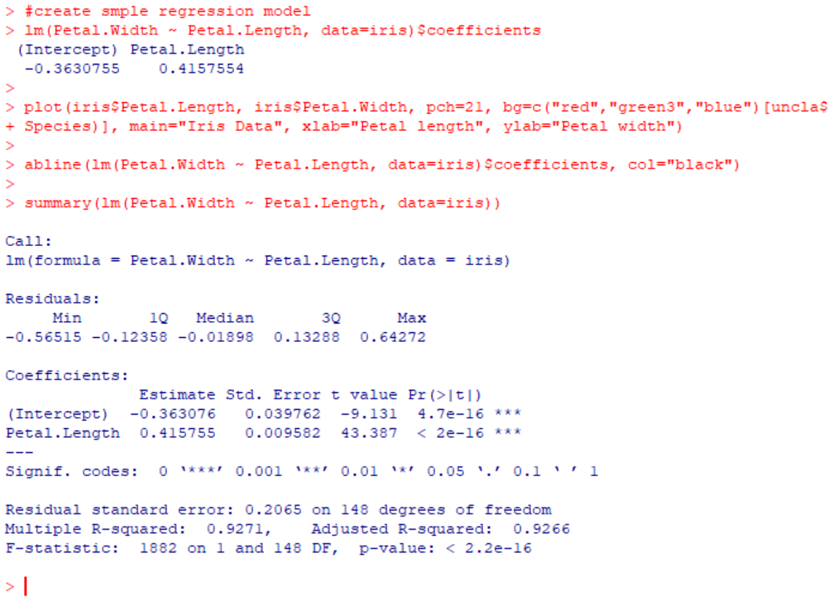



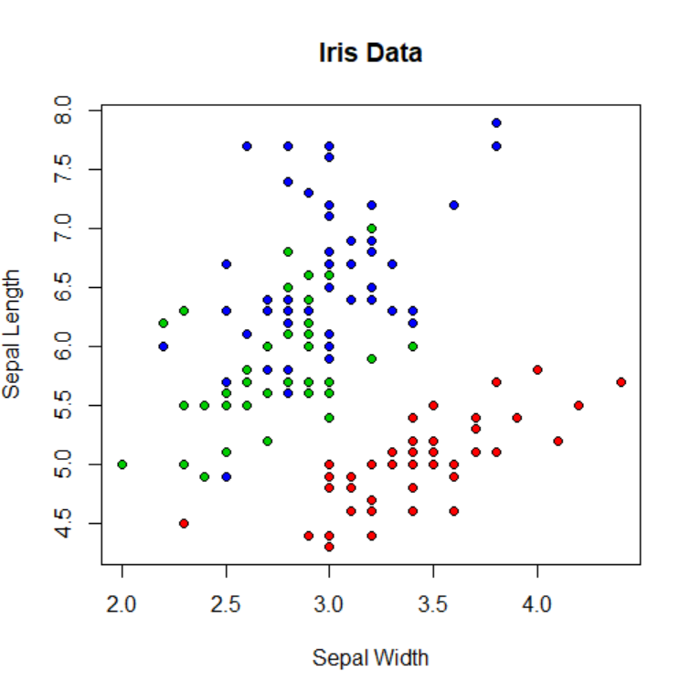 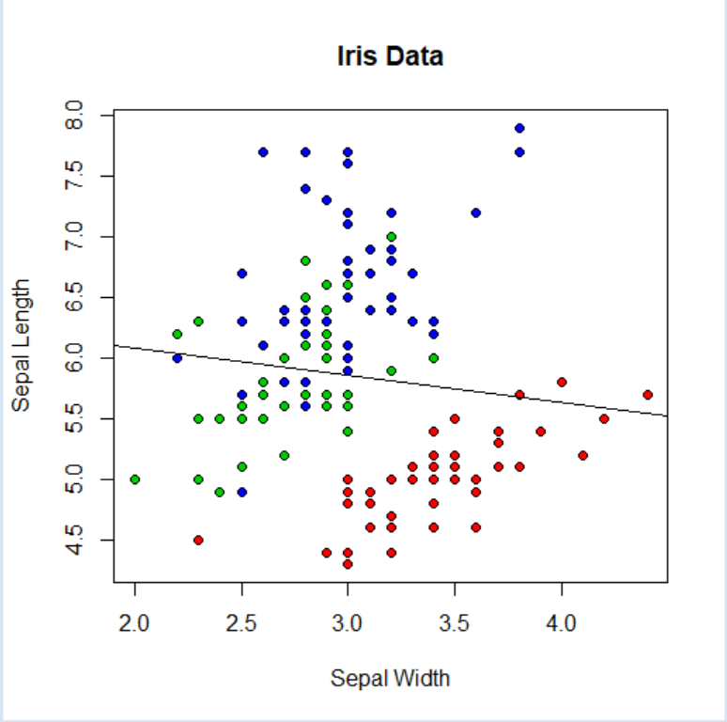

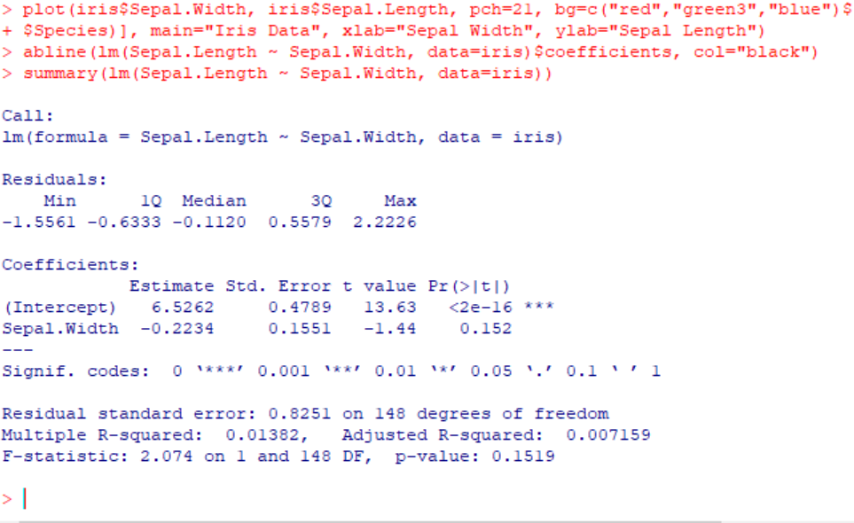

**Multiple:**

#What happens if we divide the data up by species, and run three separate linear regressions?

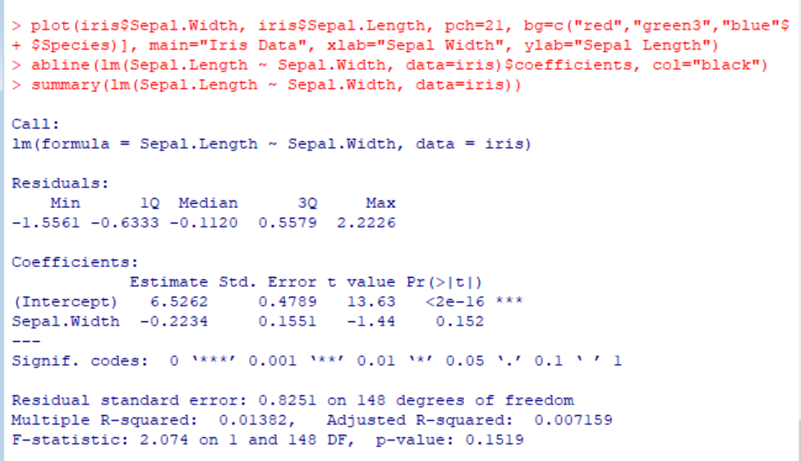

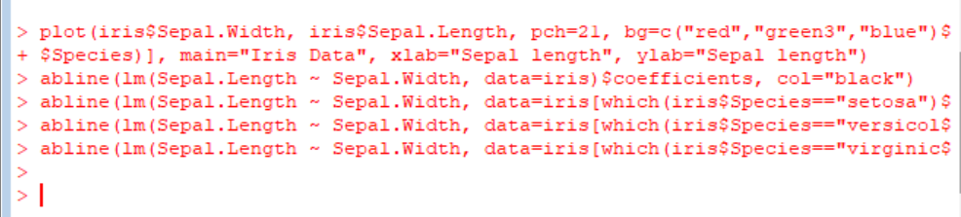

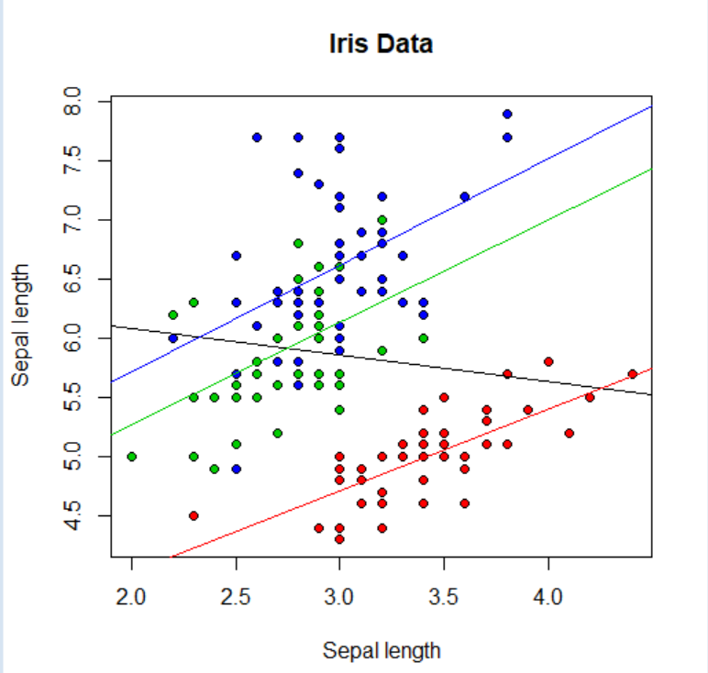

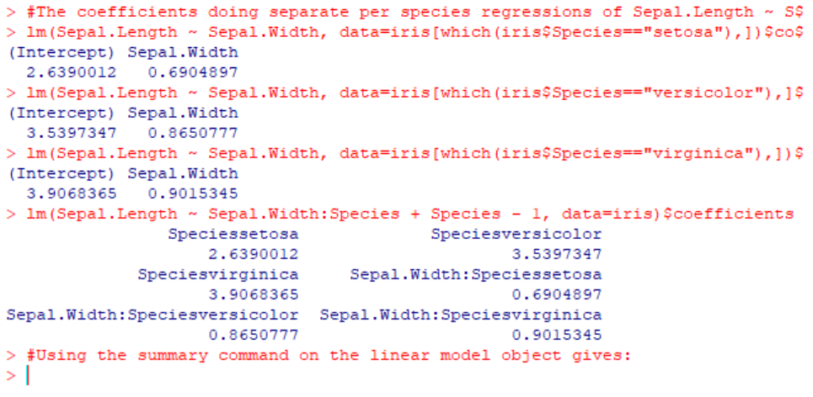

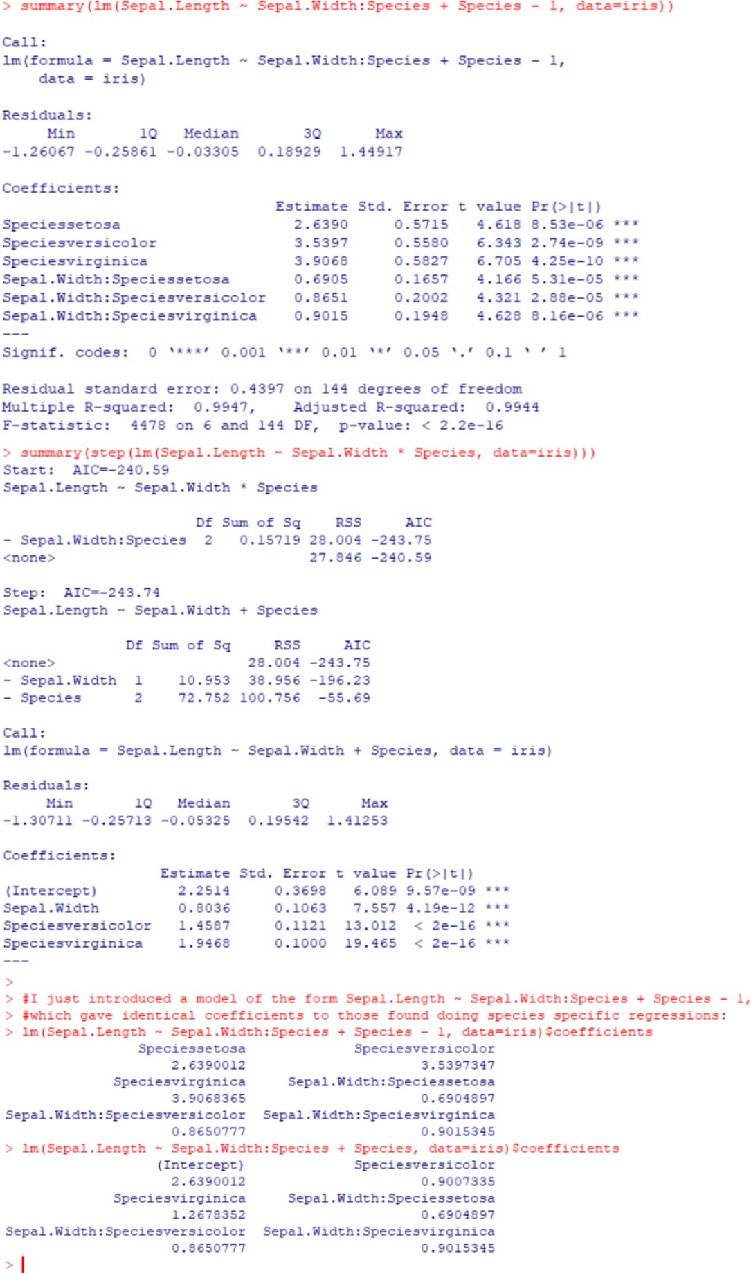

PRACTICAL NO. 7

Aim: Practical of Logistics Regression

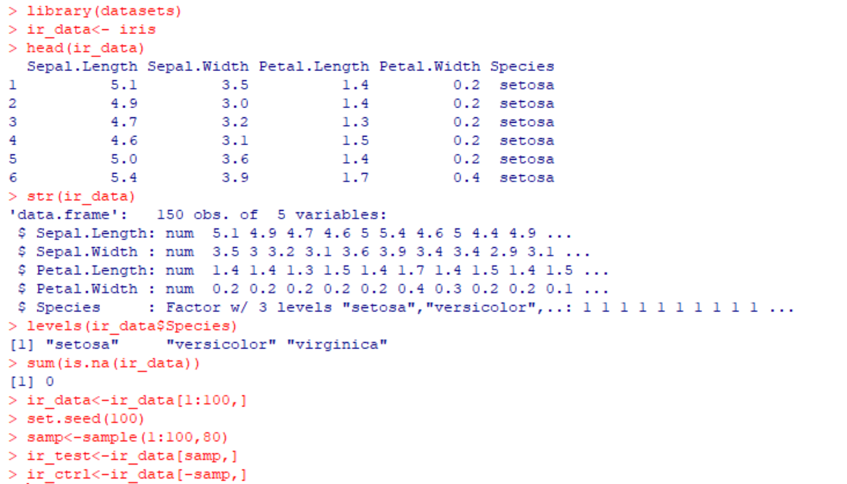

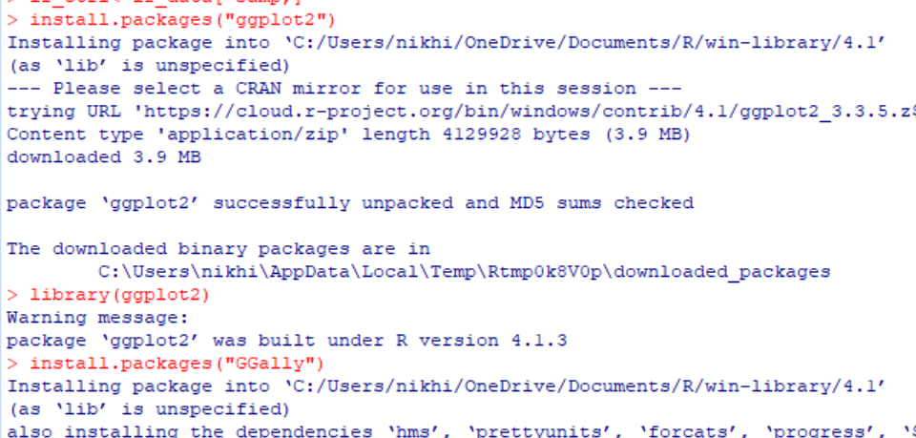 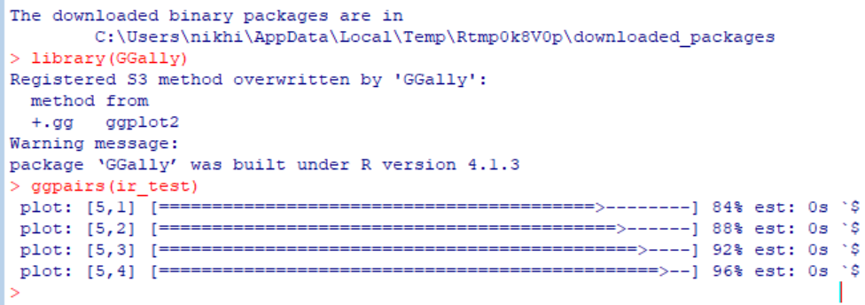

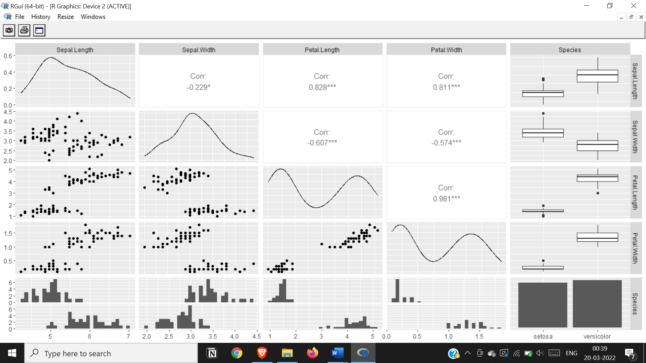

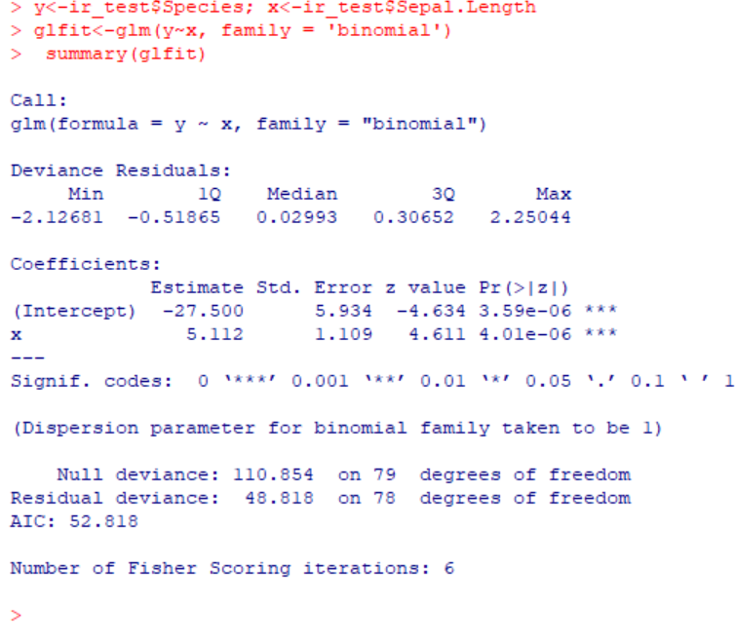

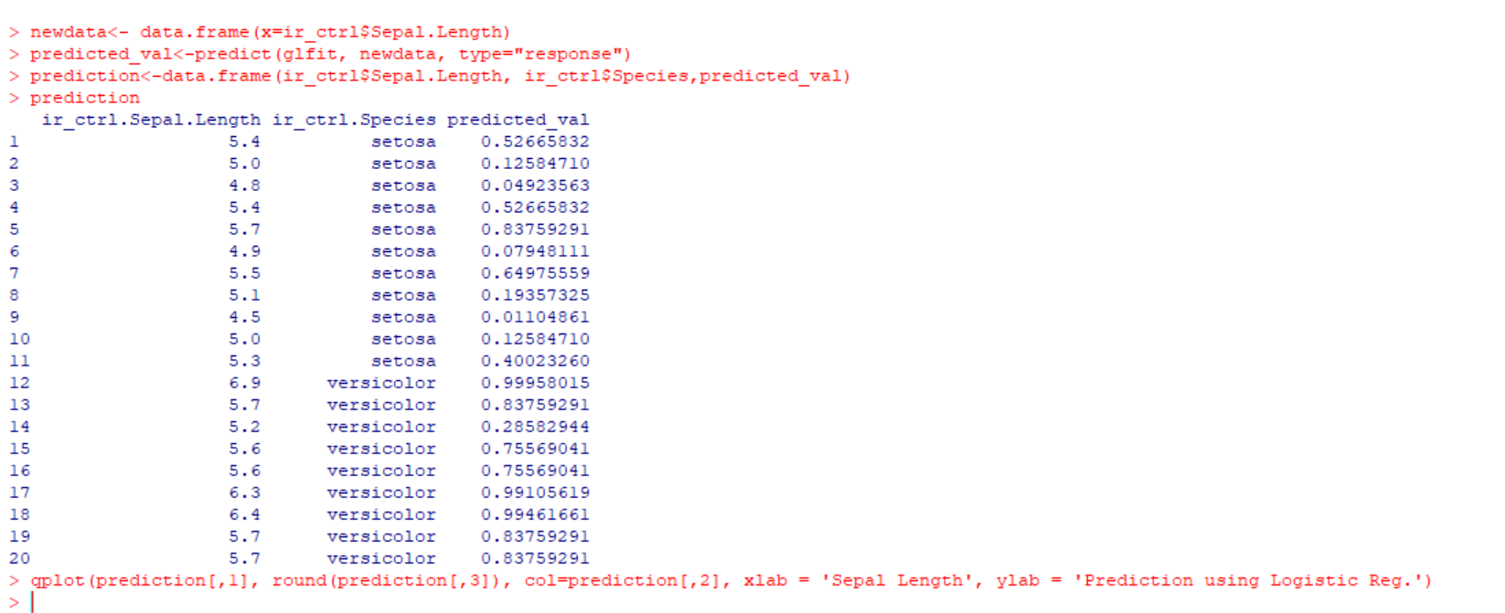

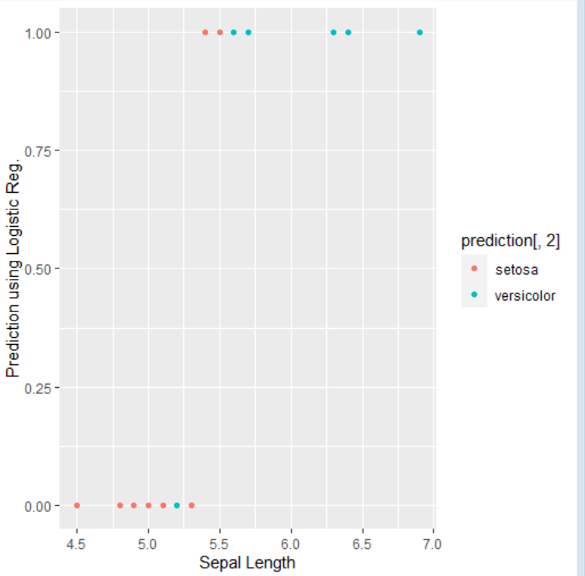

**Practical 8**

**Aim: practical of Hypothesis**

#t.test(dataset,dataset,alternative method, mu value, var.equal=F, conf.level=0.95)

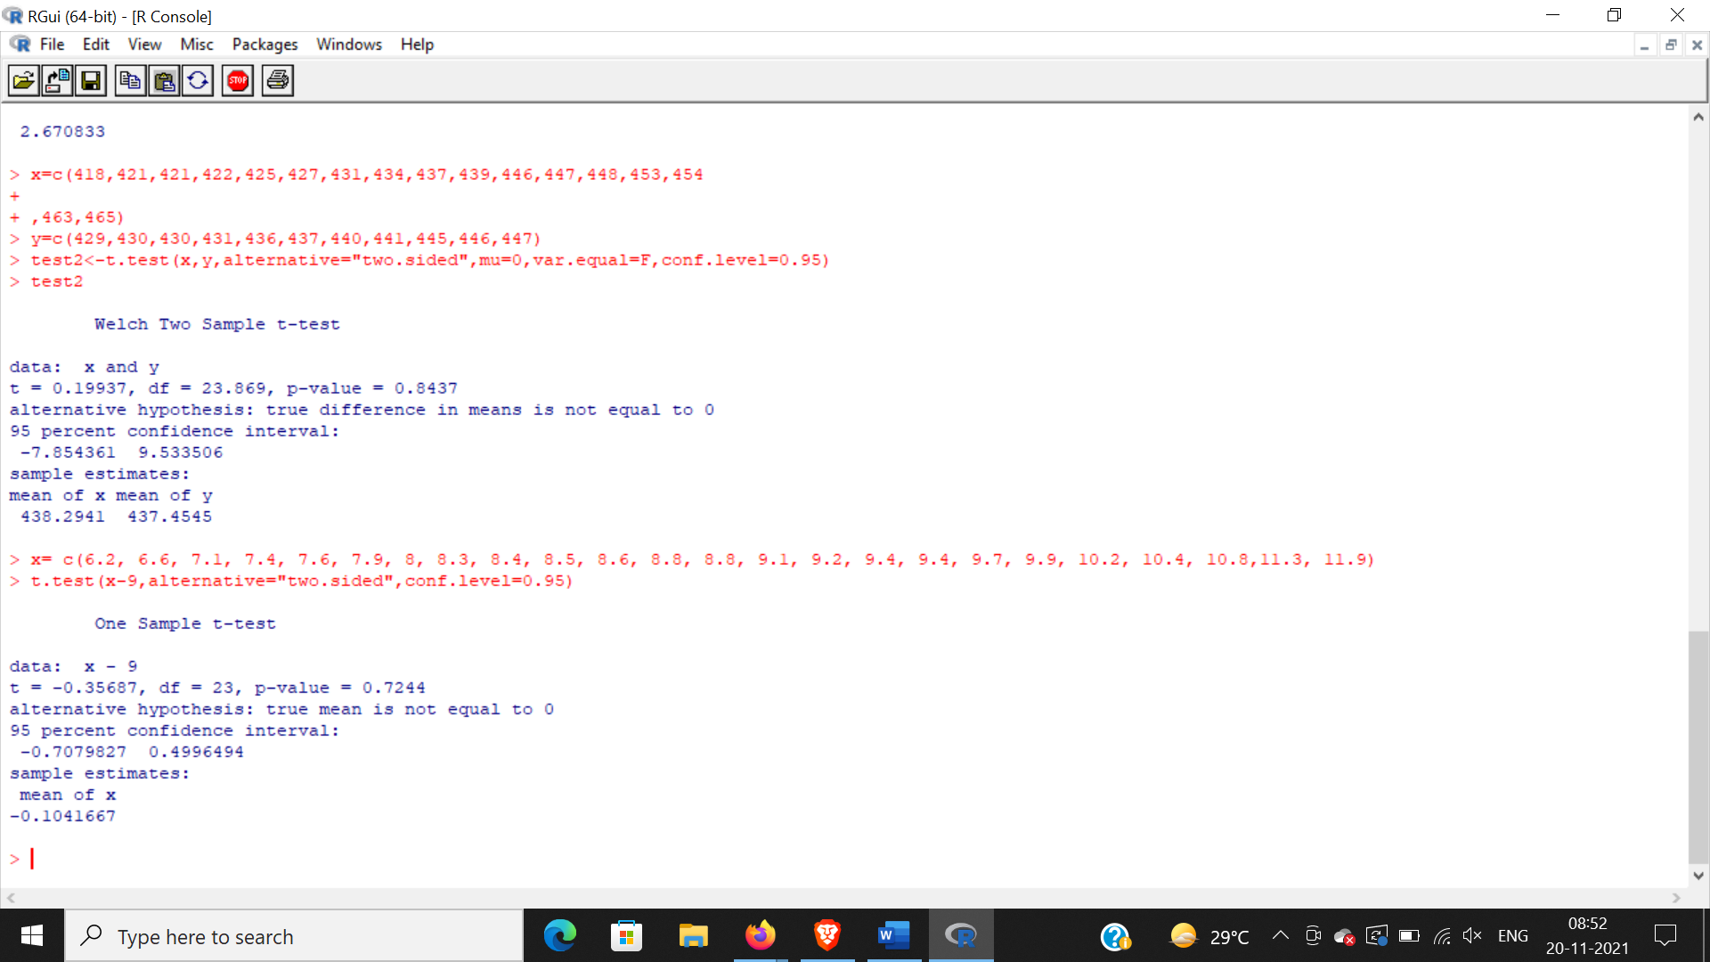

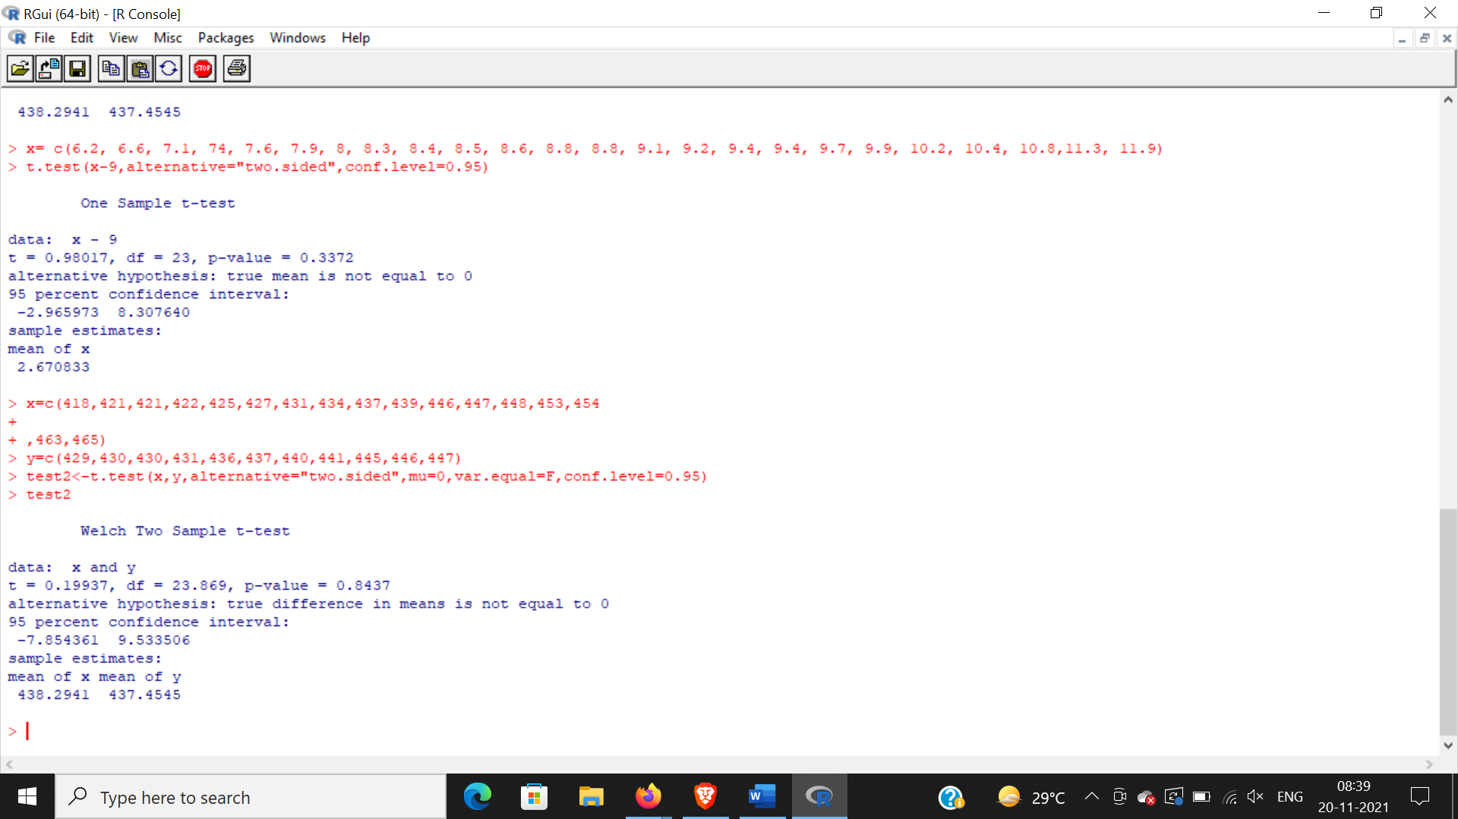

PRACTICAL NO. 9

Aim: Practical of Analysis of Variance

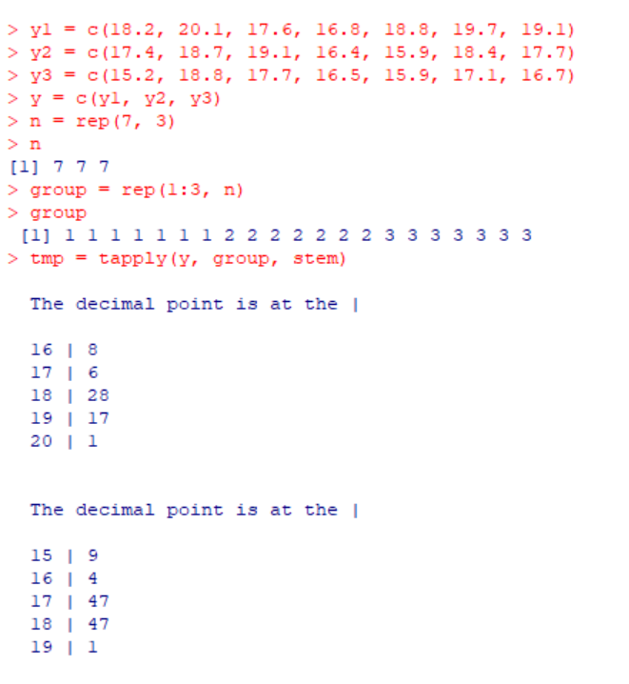

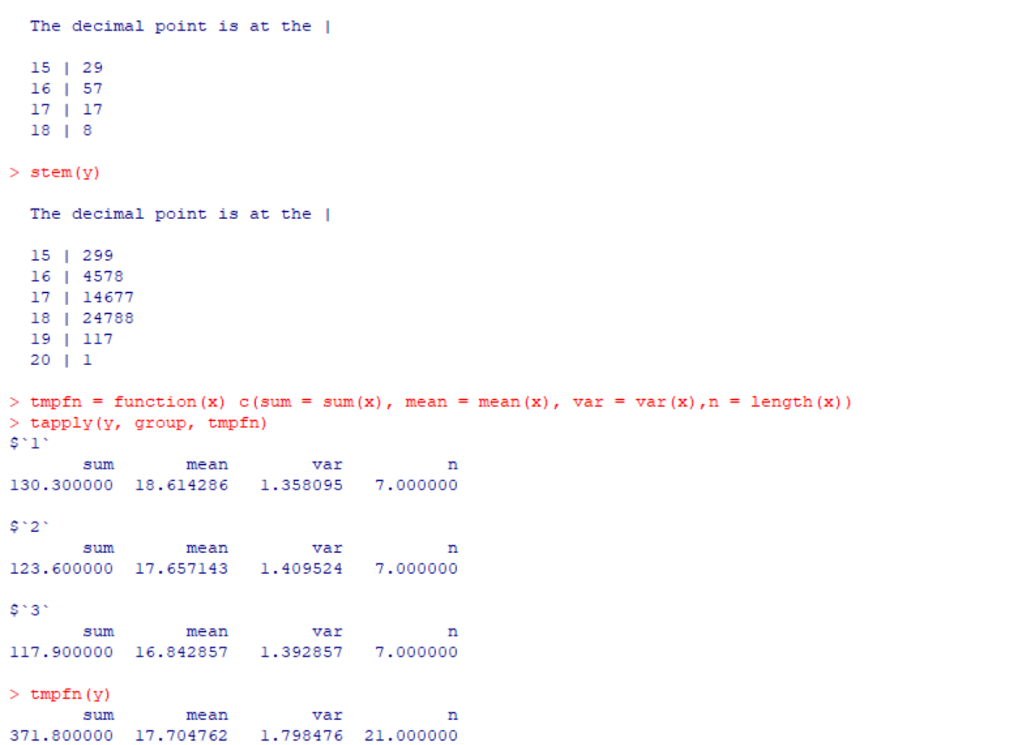

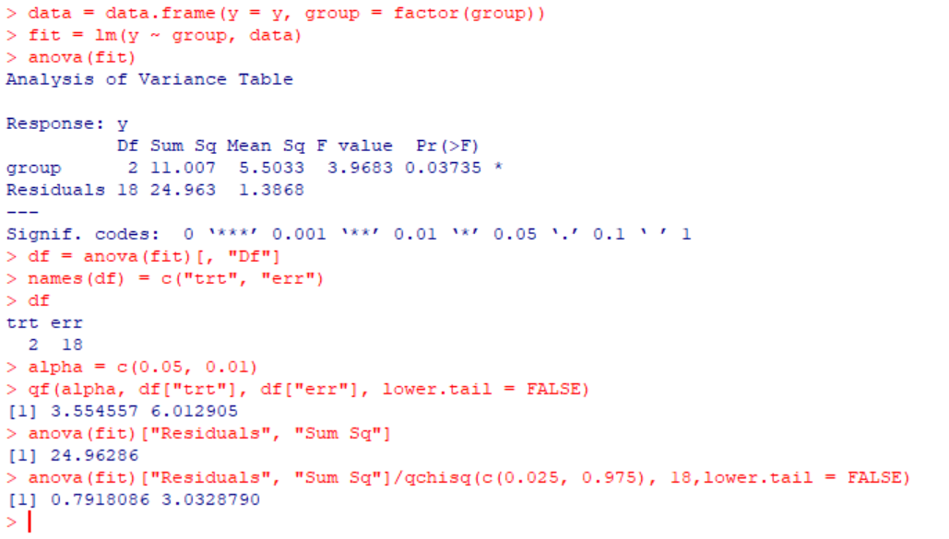

PRACTICAL NO. 10

Aim: Practical of Decision Tree